Linux workshop 07:07:2024
Done on 08 July 2024
Identify ownership of the following objects

2 /etc/passwd is owned by root



3 /var/log/messages
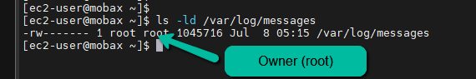

4 /usr/bin/wall
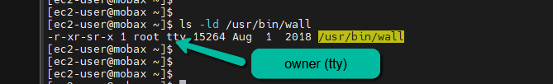

5 /var/tmp

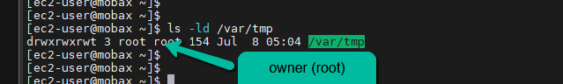

6 Compare properties of /tmp and /var/tmp

Both has the same owner and permissions

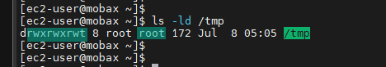



7 Give me the octal numbers for r,w,x and -

r = 4
w = 2
x = 1
(-) = 0

8 create three files file1. file2 and file3


9 add write to other for file1
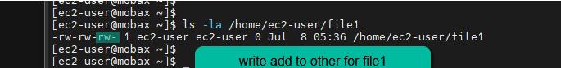

10 add execute to other for file3
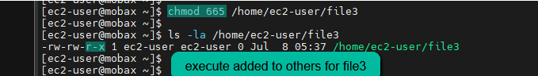

11 remove execute from other for file3
